**Project Design Phase-II**

**Technology Stack (Architecture & Stack)**

|  |  |
| --- | --- |
| Date | 18 October 2023 |
| Team ID | NM2023TMID09431 |
| Project Name | AQUATIC INSIGHTS: COGNOS POWERED WATER PORTABILITY ANALYSIS |
| Maximum Marks | 4 Marks |

**Technical Architecture:**

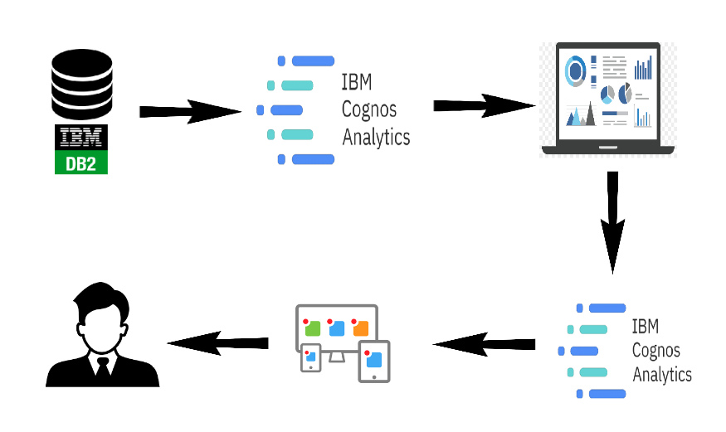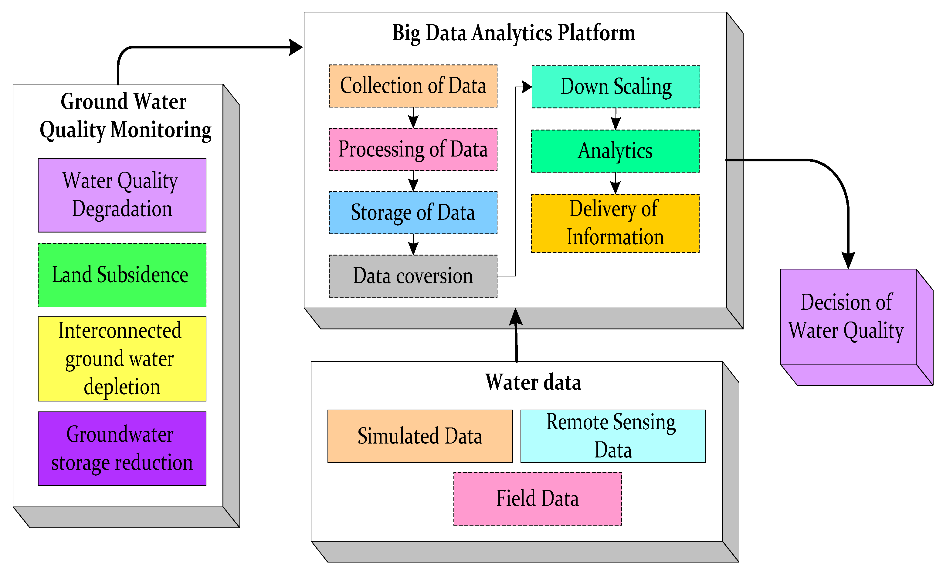

**Table-1 : Components & Technologies:**

|  |  |  |  |
| --- | --- | --- | --- |
| **S.No** | **Component** | **Description** | **Technology** |
|  | User Interface | Web Application | HTML,CSS,JAVA Script |
|  | Application Logic-1 | Enable features | IBM Cognos Analytics |
|  | Application Logic-2 | Load datasets | IBM Cognos Analytics |
|  | Application Logic-3 | Update information | IBM Cognos Analytics |
|  | Database | Configurations | IBM |
|  | Cloud Database | Database Service on Cloud | IBM Cloud |
|  | File Storage | Dataset and file Storage | IBM Cognos |
|  | External API-1 | Enable Geo Location | IBM Geo location API |
|  | External API-2 | Application Interface | Java API |
|  | Machine Learning Model | Regression | Cognos Analytics |
|  | Infrastructure (Server / Cloud) | Application Deployment on Local System / Cloud Local Server Configuration: Cloud Server Configuration : | IBM Cognos Analytics |

**Table-2: Application Characteristics:**

| **S.No** | **Characteristics** | **Description** | **Technology** |
| --- | --- | --- | --- |
|  | Open-Source Frameworks | The frameworks promote collaboration, innovation, and community-driven development. | IBM Cognos,  JavaScript, |
|  | Security Implementations | Robust security implementations are essential to safeguard sensitive information and ensure the integrity and confidentiality of data. | Django, Flask |
|  | Scalable Architecture | Scalability can be achieved through techniques such as load balancing, horizontal or vertical scaling, and cloud-based solutions. | IBM Cloud |
|  | Availability | High availability ensures that users can access applications and data without interruptions. | MySQL |
|  | Performance | High-performance systems can process tasks quickly, handle concurrent user requests efficiently, and deliver optimal response times. | IBM Cognos |